**DAY 2**

**EXPERIMENT-9**: LEX program to find the length of the longest word.

%{

#include <stdio.h>

#include <string.h>

char longest_word[256];

int longest_length = 0;

%}

%%

[^\n\t ]+ {

int length = strlen(yytext);

if (length > longest_length) {

longest_length = length;

strcpy(longest_word, yytext);

}

}

%%

int main(int argc, char *argv[]) {

yylex();

printf("The longest word is: %s\n", longest_word);

return 0;

}

int yywrap() {

return

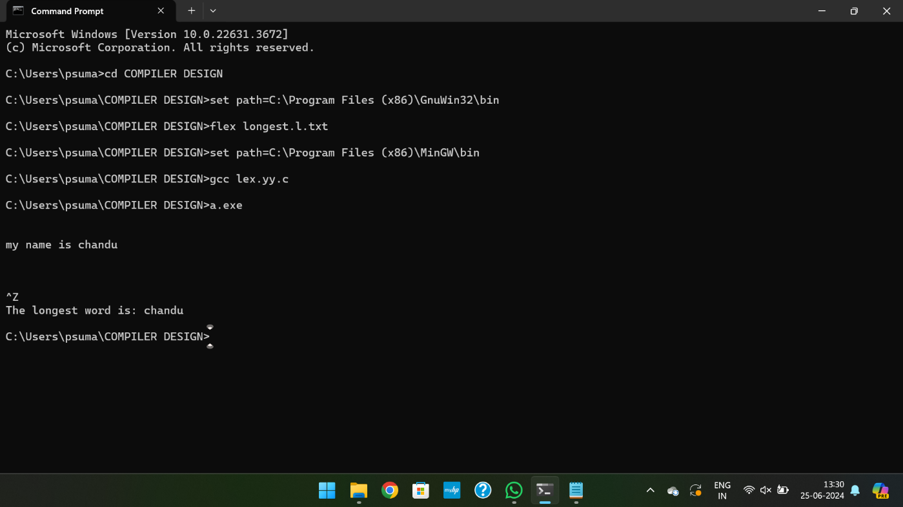

**EXPERIMENT-10**: LEX program to validate the URL.

%{

%}

%%

"https://www."[a-z]+".com" {printf("\nURL valid\n");}

.+ {printf("\nURL invalid\n");}

%%

int yywrap(){

return 1;

}

int main()

{

printf("Enter URL:");

yylex();

printf("\n");

return 0;

}

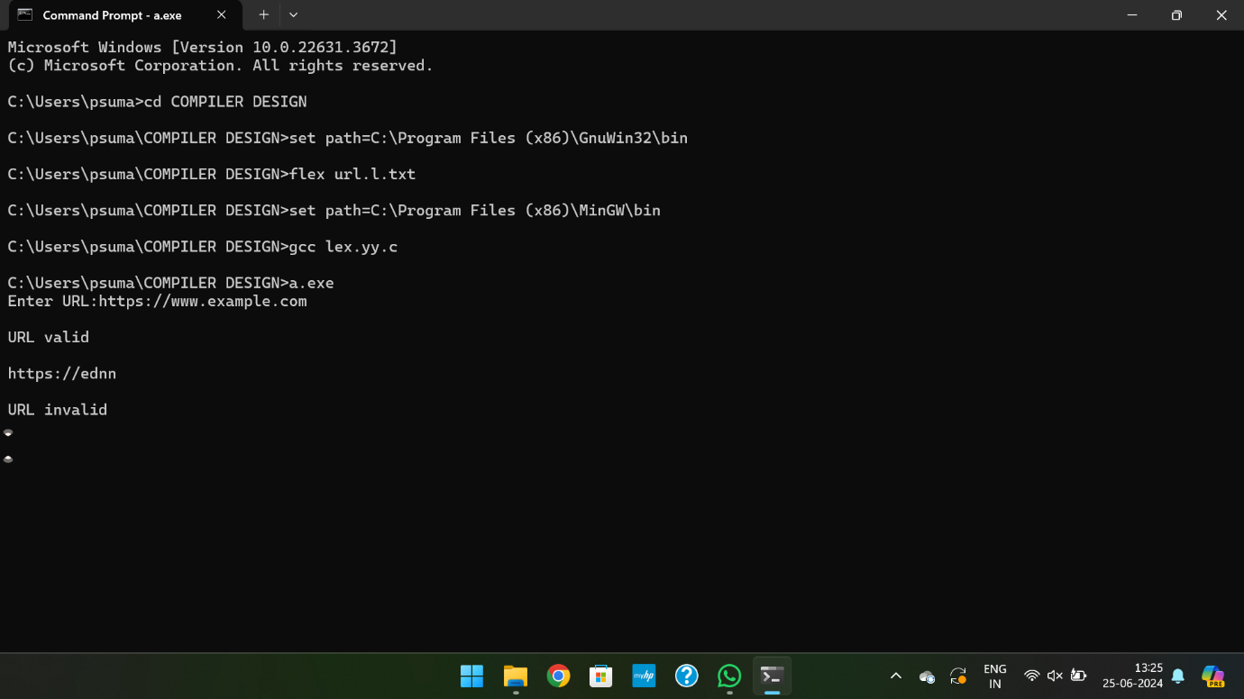

**EXPERIMENT-11**: LEX program to validate DOB.

%{

#include<stdio.h>

%}

%%

[0-3][0-9]\/[0-1][0-9]\/[0-9]{4} {printf("valid");}

.+ {printf("invalid");}

%%

int yywrap(){}

int main()

{

printf("Enter the DOB:\n");

yylex();

}

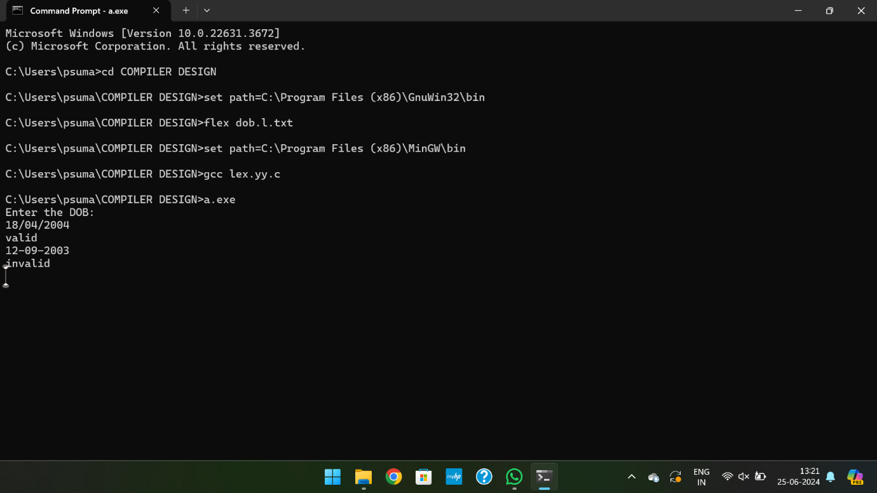

**EXPERIMENT-12**: LEX program to recognize a word and relational operator.

%{

#include <stdio.h>

%}

%%

[a-zA-Z]+ { printf("WORD: %s\n", yytext); }

"=="|"<="|">="|"!="|"<"|">" { printf("REL_OP: %s\n", yytext); }

[ \t\n]+

. { printf("UNRECOGNIZED: %s\n", yytext); }

%%

int yywrap() { return 1;}

int main()

{

yylex();

return 0;

}

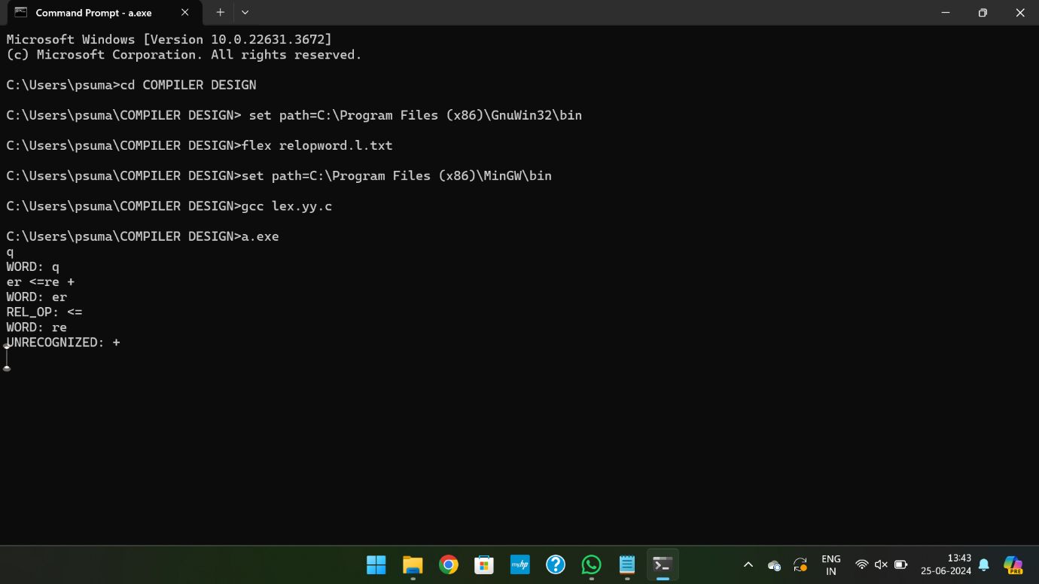

**EXPERIMENT-13**: LEX code to replace a word with another word in a file.

%{

#include<stdio.h>

#include<string.h>

char replace_with [] = "hello";

char replace [] ="world";

%}

%%

[a-zA-Z]+ { if(strcmp(yytext, replace)==0)

fprintf(yyout, "%s", replace_with);

else

fprintf(yyout, "%s", yytext);}

. fprintf(yyout, "%s", yytext);

%%

int yywrap()

{

return 1;

}

int main()

{

extern FILE *yyin, *yyout;

yyin=fopen("rwinput.txt", "r");

yyout=fopen("rwoutput.txt", "w");

yylex();

}

**INPUT:** rwinput.txt:

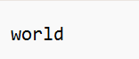

**OUTPUT:** rwoutput.txt:



**EXPERIMENT-14**: LEX code to do basic mathematical operations.

%{

#include<stdio.h>

%}

%%

"="|"+"|"-"|"/"|"*" {printf("valid");}

.+ {printf("Invalid");}

%%

int yywrap(){}

int main()

{

printf("Enter the input:");

yylex();

return 0;

}

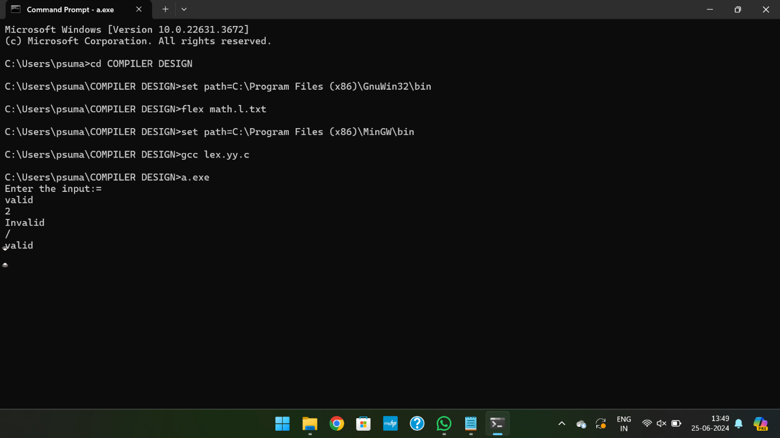

**EXPERIMENT-15**: LEX Program to check the email address is valid or not.

%{

%}

%%

[a-z.0-9_]+@[a-z]+".com"|".in" {printf("it is valid");}

.+ {printf("it is not valid");}

%%

int yywrap()

{}

int main()

{

printf("Enter the mail:");

yylex();

}

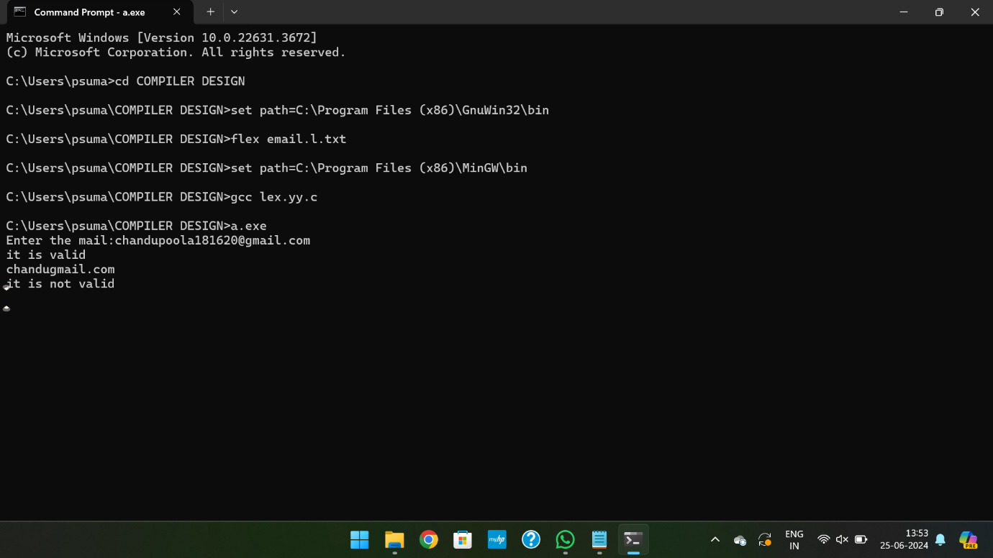

**EXPERIMENT-16**: LEX Program to convert the substring abc to ABC from the given input string.

%{

#include <stdio.h>

%}

%%

[a-z] { printf("%c", yytext[0] - 32); }

[^a-z]+ { printf("%s", yytext); }

%%

int yywrap(void) {

return 1;

}

int main() {

printf("\n Enter the string: ");

yylex();

return 0;

}

